BANK MANAGEMENT SYSTEM

Course: Programming in C
Name: Lavanya Singh
Sap ID: 590027144
Batch: 46
Submitted To: Mrs. Dolly Das

1. Introduction

This project, Bank Management System, is a console-based application built using the C programming language.
It allows users to perform essential banking activities such as creating accounts, depositing and withdrawing money, viewing account details, and deleting accounts. To ensure that account data is stored permanently, the system uses binary file handling.
This project demonstrates fundamental concepts of C including structures, arrays, loops, file handling, and menu-driven programming.

2. Objectives

The main objectives of this project are:
- To develop a simple and user-friendly banking application.
- To store and retrieve account information using file handling.
- To implement basic banking operations.
- To demonstrate the use of C structures, arrays, loops, and functions.
- To understand how real-world systems store and manage user data.

3. System Design

Data Structure Used

struct account {
int acc_no;
char name[50];
float balance;
};

Major Functions

Function Name | Purpose
loadData() | Load saved accounts from file
saveData() | Save all records to file
createAccount() | Create new customer account
viewAccount() | Display details of a single account
deposit() | Add money to a customer account
withdrawMoney() | Withdraw money with balance checking
deleteAccount() | Remove an account
viewAll() | Display all stored accounts

4. Outputs and Results:

- CREATE A NEW ACCOUNT

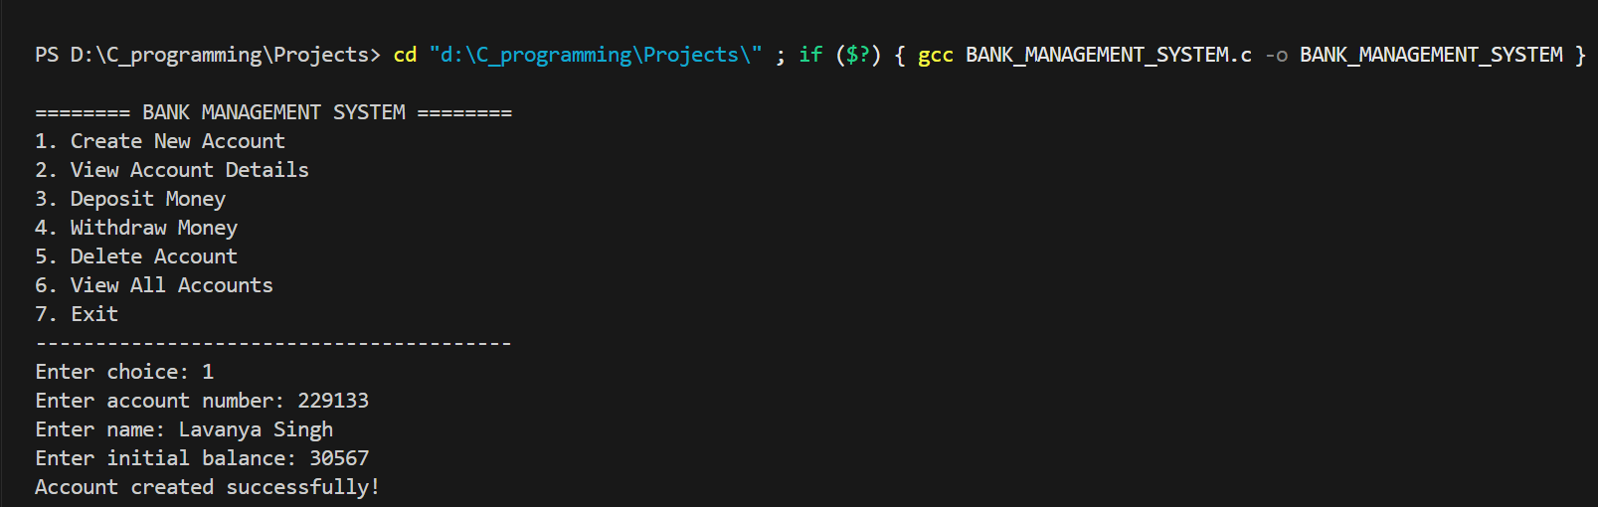

- VIEW ACCOUNT DETAILS

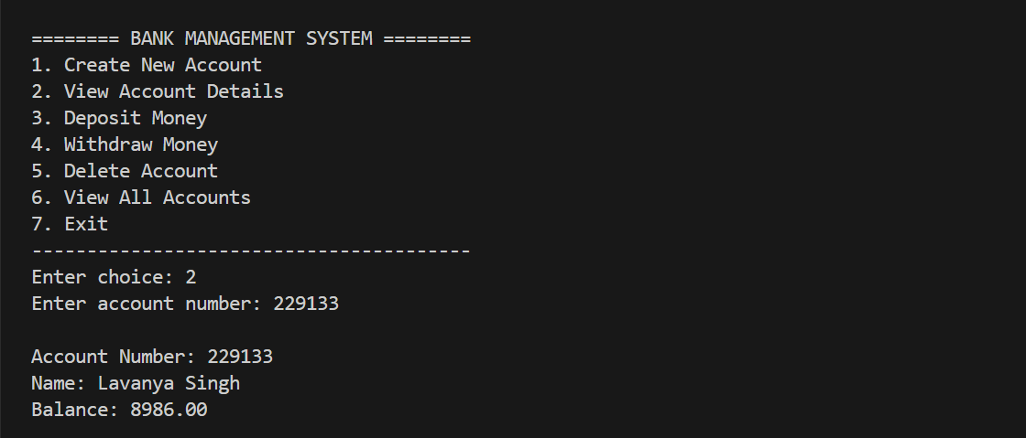

- DEPOSITE MONEY

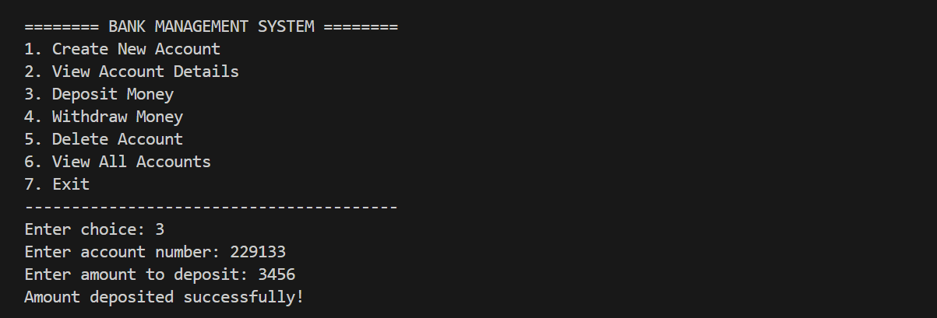

- WITHDRAW MONEY

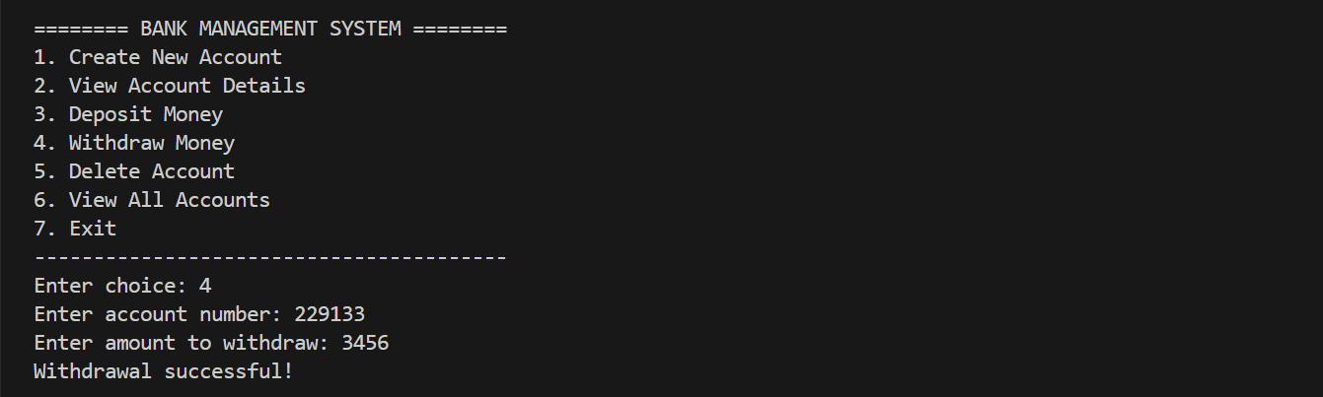

- DELETE ACCOUNT

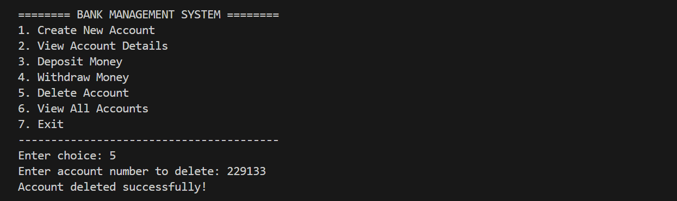

- VIEW ALL ACCOUNTS

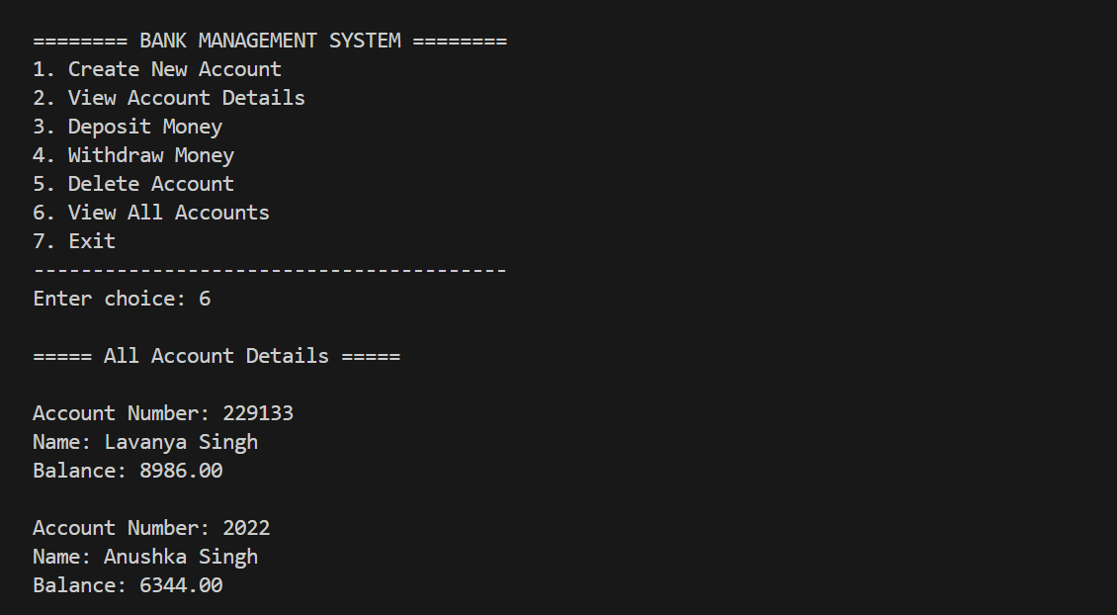

- EXIT

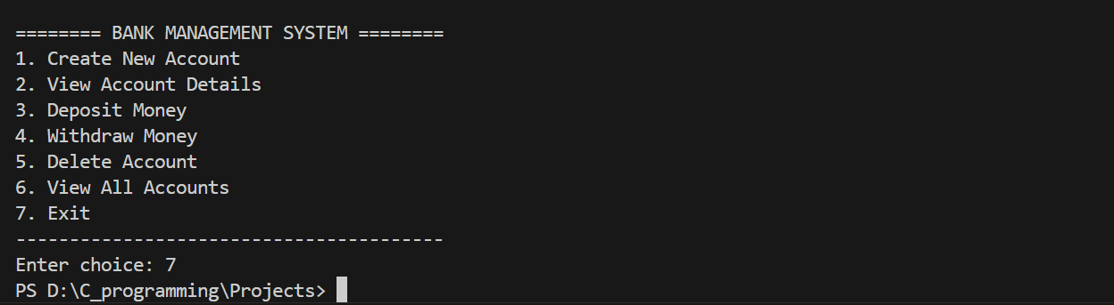

5. Conclusion and Future Enhancements

The Bank Management System project demonstrates how basic banking operations can be implemented using C programming concepts such as structures, arrays, file handling, and functions.
It provides a practical understanding of how data is stored, retrieved, and manipulated in real-world applications.
This project lays a strong foundation for building more advanced and secure financial management systems in the future.

Future Enhancements

- Login system with admin and user privileges.
- Unlimited account storage using linked lists or databases.
- Adding interest, loan, or fixed deposit features.
- Generating mini-statements or transaction history.
- GUI version using C++, Java, or Python.
- Integration with SQL database for large-scale usage.

